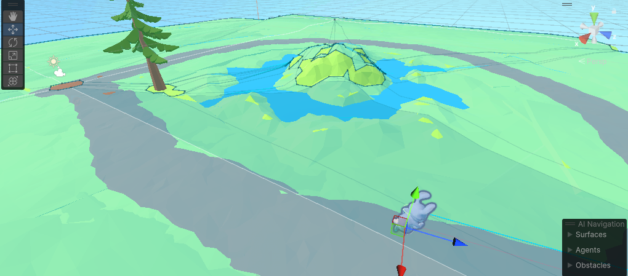

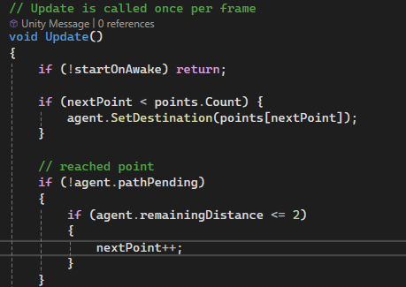

1 Implementation of a custom NavMesh path with checkpoints.

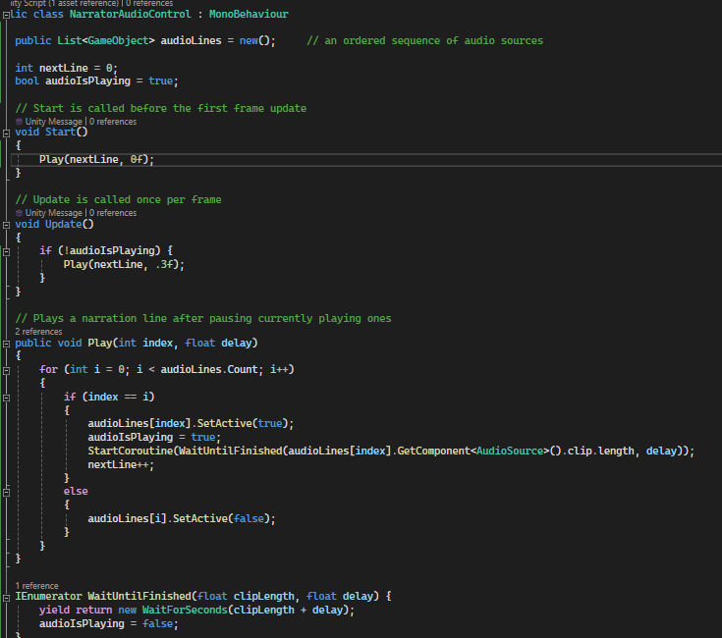

2 Script to control the sequence of audio lines.

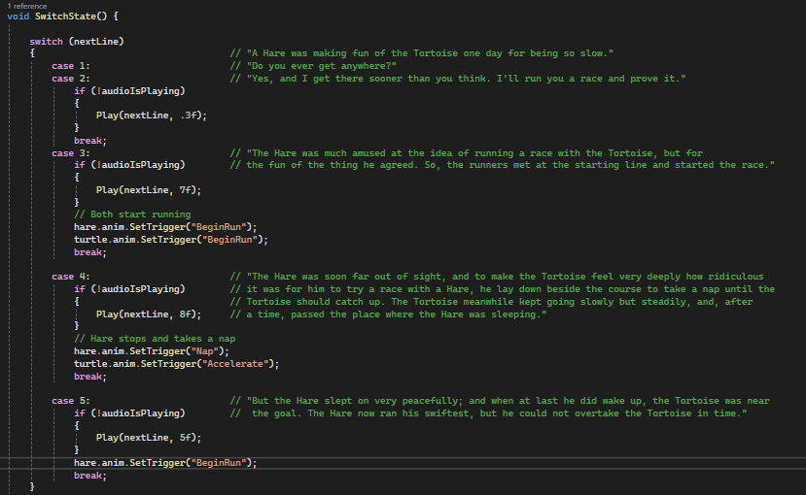

3 Completed the animation sequence of the dream scene. Added audio lines, AI navigation and Character Animations.

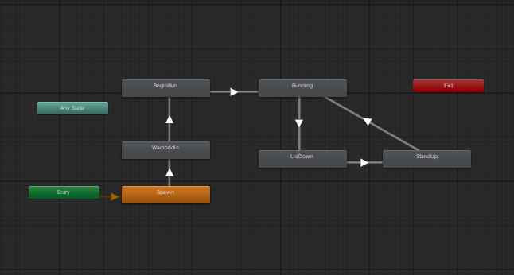

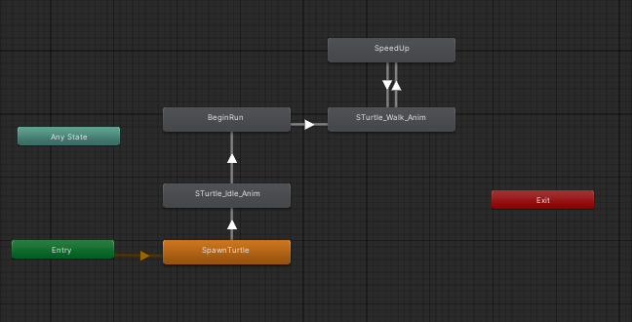

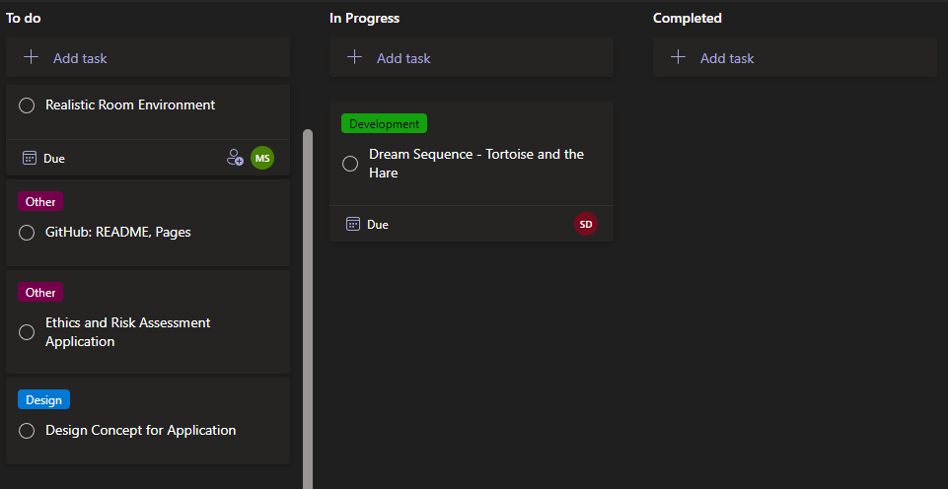

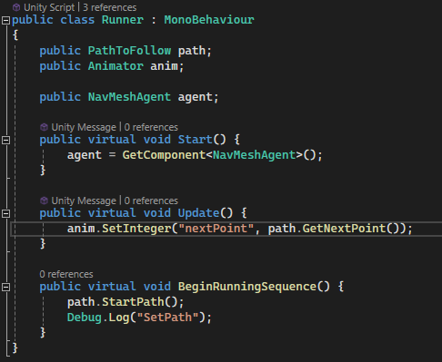

4 "Runner" parent class for both hare and turtle script.

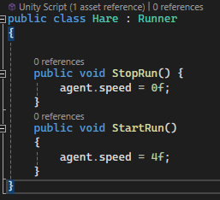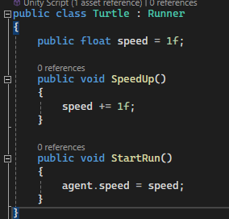

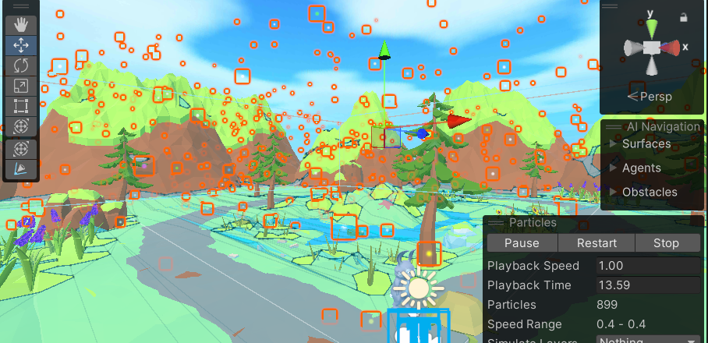

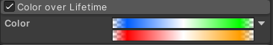

5 Colourful particle system.

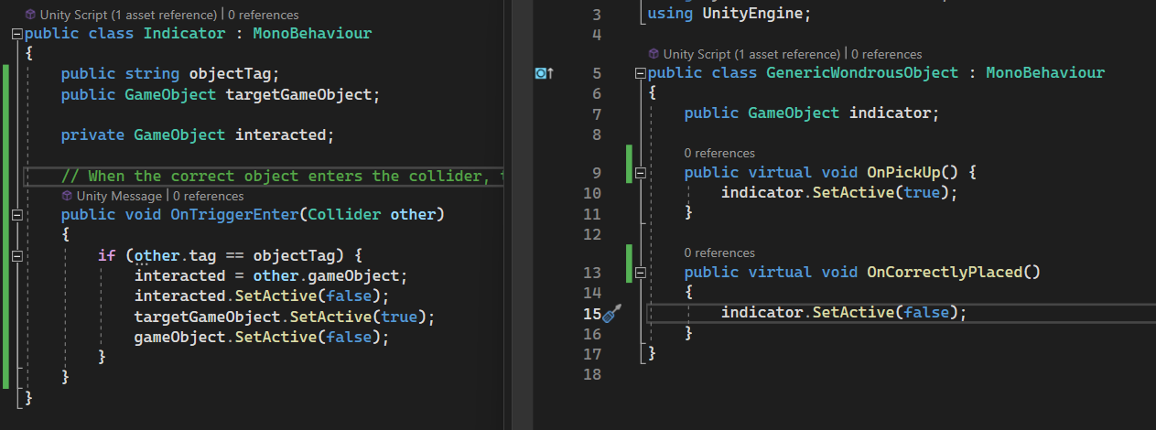

6 Following a merge with scott's branch, started implementing the features in the bedroom. Created a “GenericWondrousObject” script. This script will manage the features of objects that can be picked up and positioned to a target location. Each wondrous object will inherit from this script and apply their own special effects. The target location will be highlighted to the player by an “indicator” object.

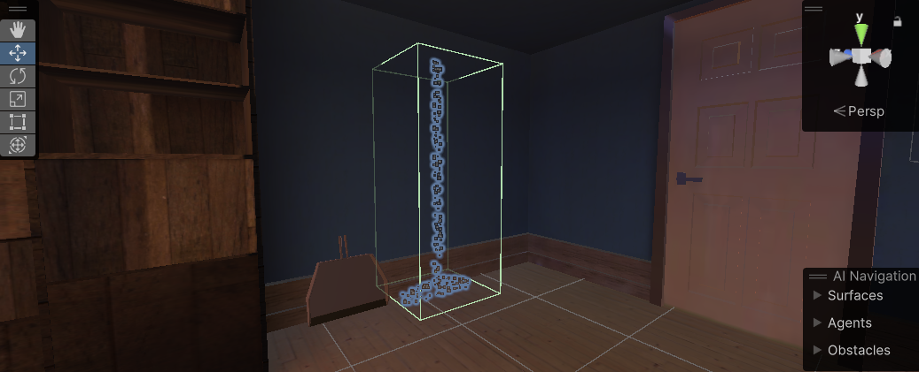

7 The indicator for each wondrous object's target location is a particle system in the shape of the object.

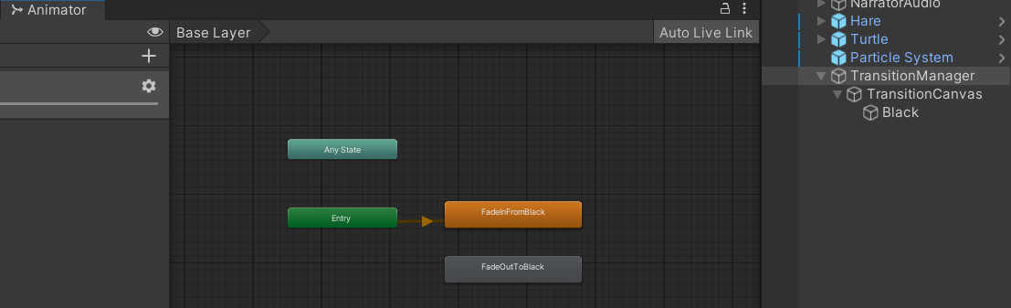

8 Added a fade to/from black effect between the transitions of the scenes.

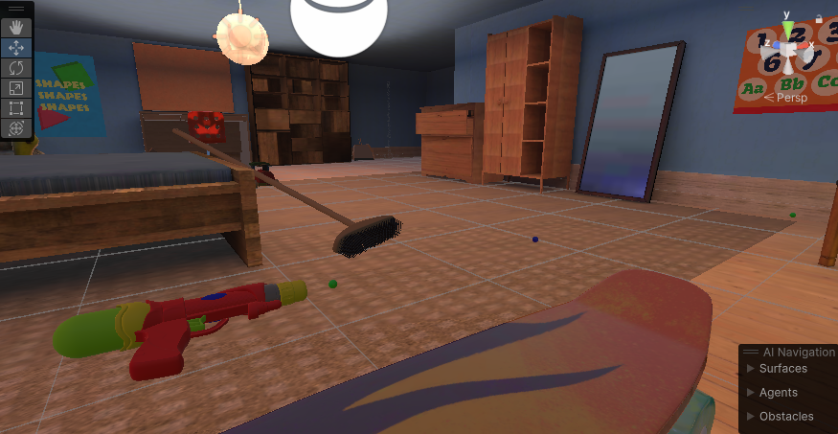

9 Added a toy gun that shoots on grab activated.

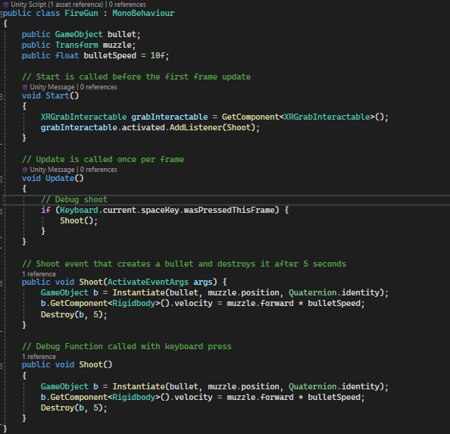

10 Script for the shooting event. The hit detection will be implemented with collision with the actual bullet prefab.

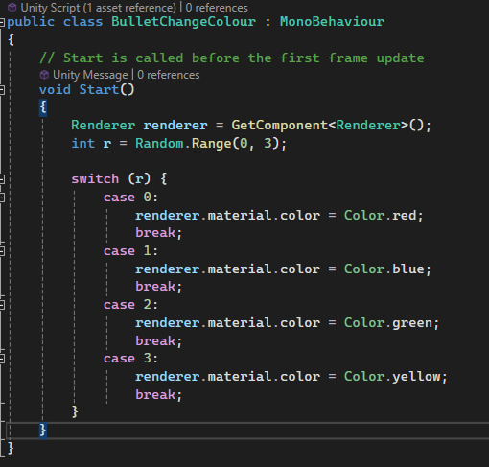

11 Script to randomise the colour of the bullet.

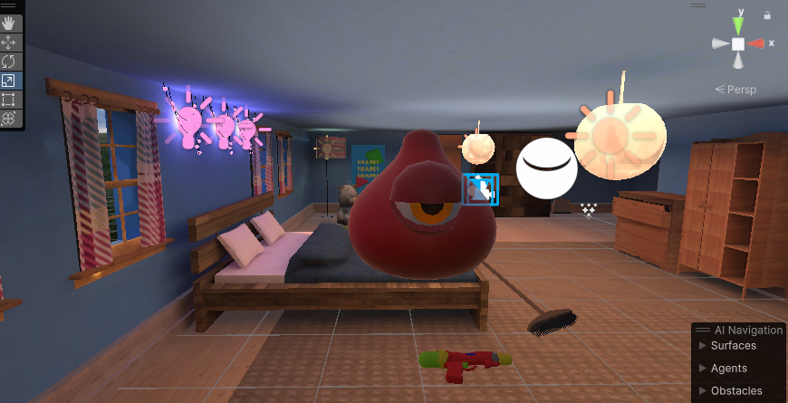

12 Slime asset for the shooting event. Used the Lazy Follow script to make it face the main camera.

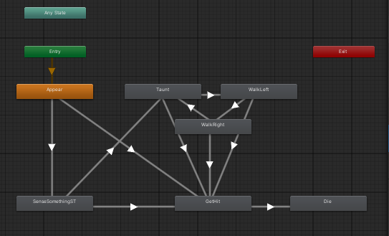

13 Animator for the slime.

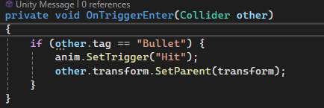

14 When a bullet hits a slime.

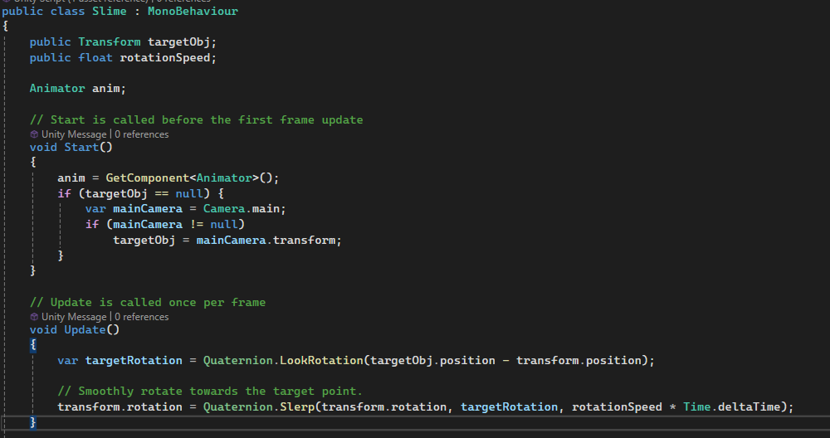

15 Removed the LazyFollow component and implemented a custom smooth “lookat” script.

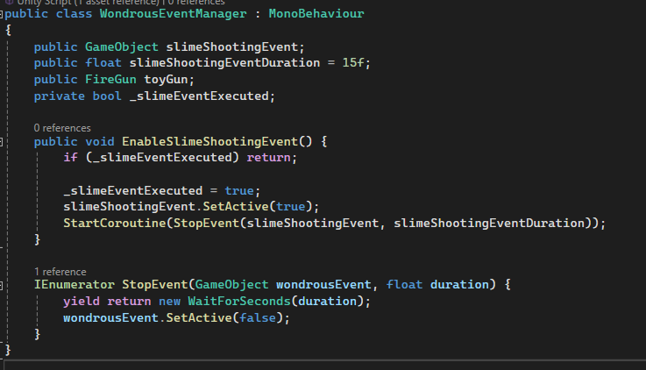

16 Event Manager script for enabling and disabling each event.

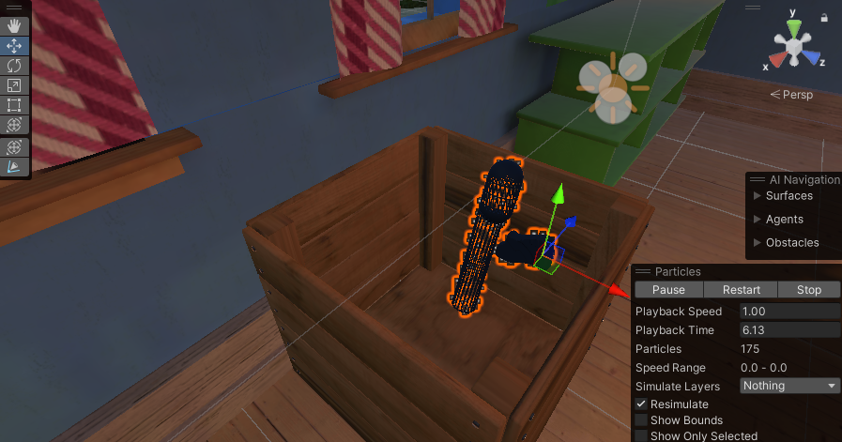

17 Created indicator for the toy gun.

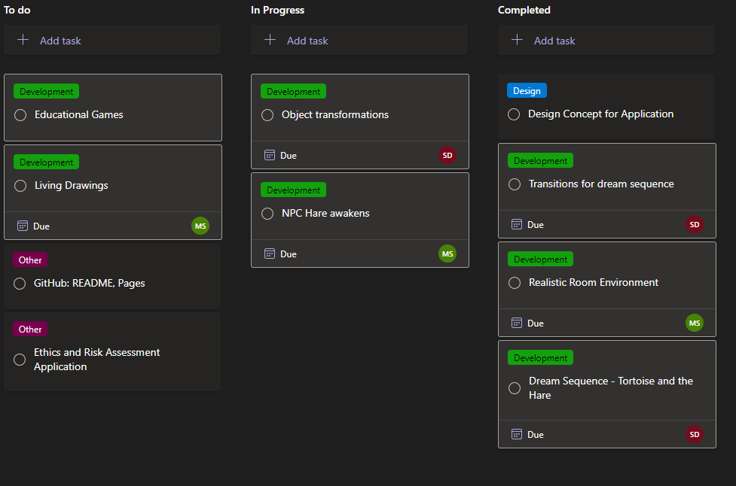

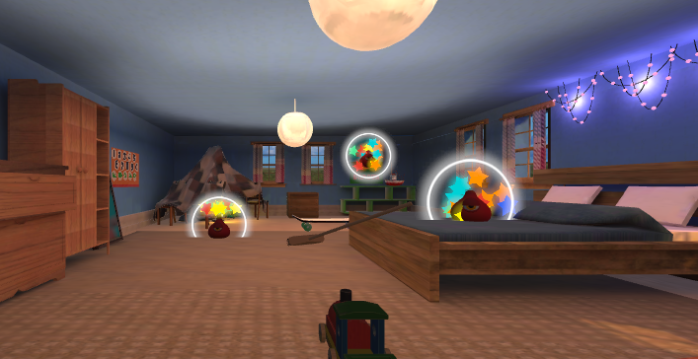

18 Added particle effect on the appearance of the slimes.

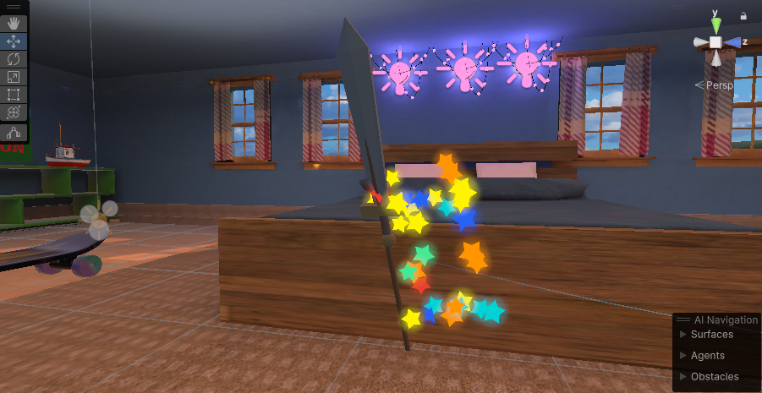

19 Broom transformation into sword.

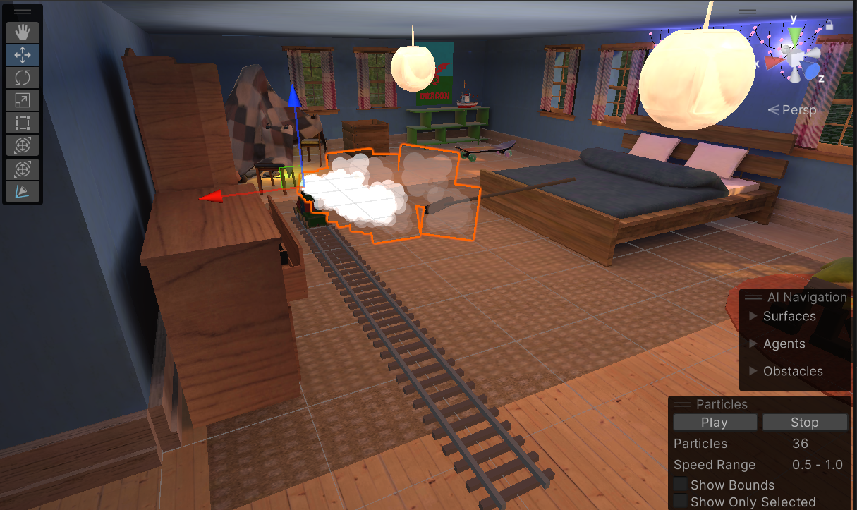

20 Create train animation with particle systems. Made a railroad system with tracks that appear gradually.

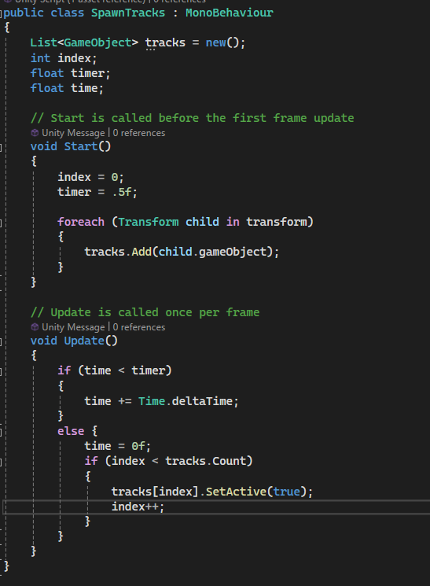

21 Script to make tracks appear one at a time.

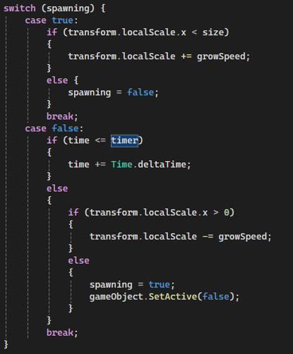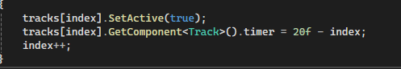

22 Implemented tracks despawning in reverse order

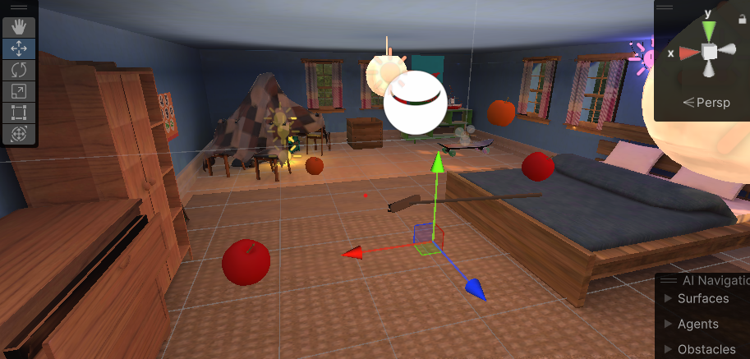

23 Added floating apples to the sword event that implement the EzySlice algorithm.

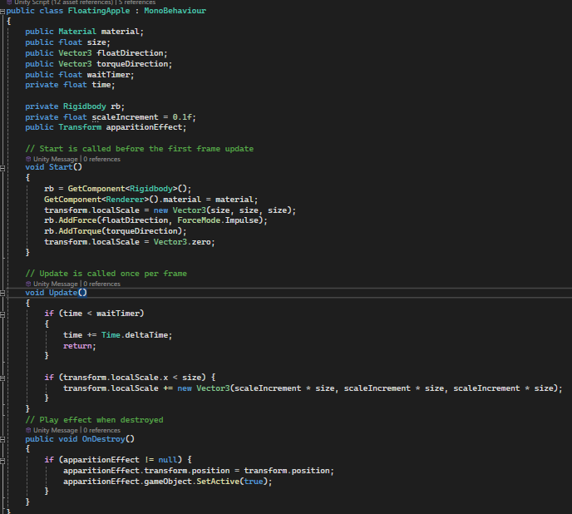

24 Script that adds force to the rigidbodies of the apple to make them float and spin.

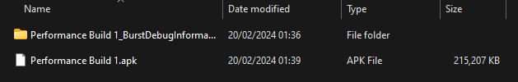

25 Performance build. Optimization needed.

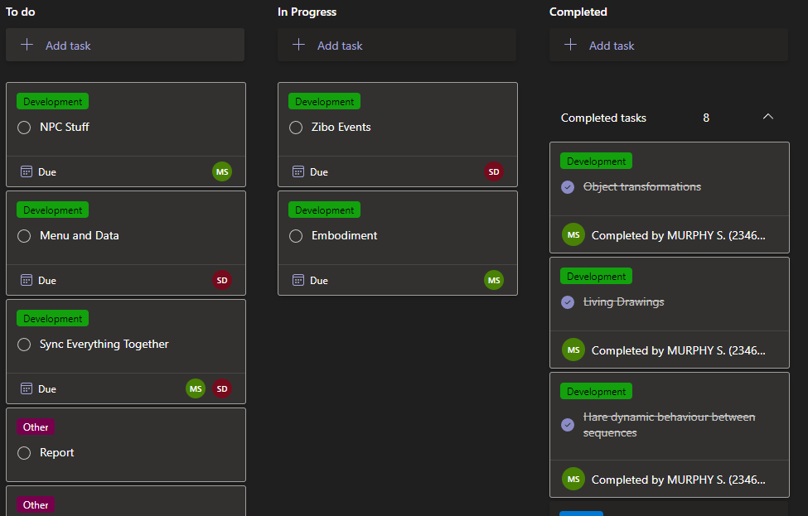

26 Merged the two scenes into master scene. Removed Curtains for performance.

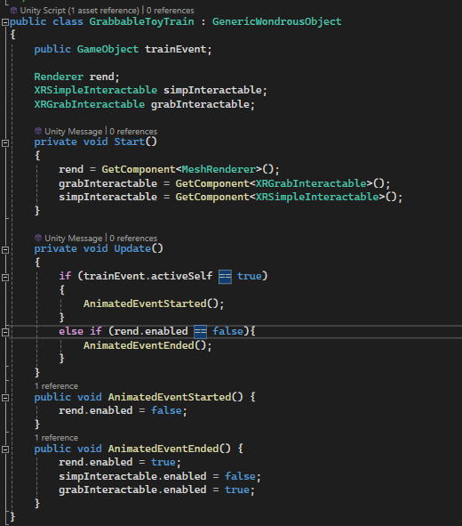

27 Script that replaces the toy train with the animated train during the animation sequence.

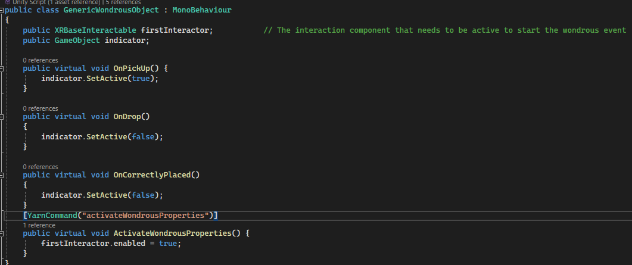

28 Added a YarnCommand function to the wondrous object class to allow the wondrous events to not be available at start. This allows each of the wondrous events to be enabled one-by-one as the hare takes the player through them.

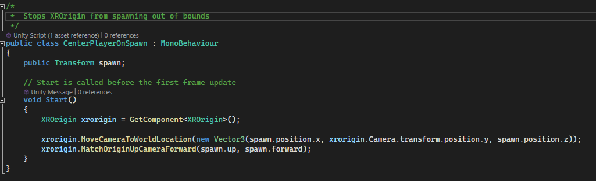

29 Script for ensuring XROrigin spawns in the same position.

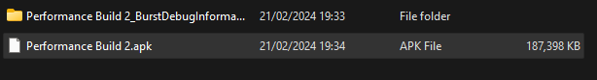

30 Performance is perfect without the curtains. For some reason the apples do not spawn in the build.

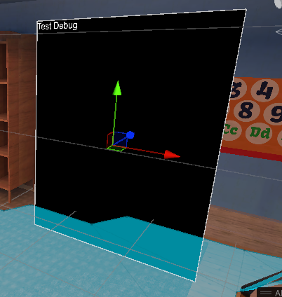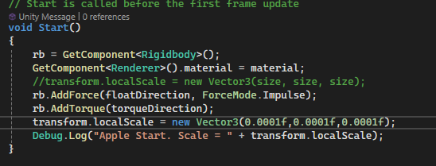

31 With the previous code, the Android build of the app was not able to play the spawn effect of the apples. This issue was unique to the .apk build, as it did not present in the Editor nor in a Windows build. Created an in-app Debug Log panel to find the issue. Turns out initialising the localScale of an object to Vector3.zero would completely nullify any subsequent modifications to its position or size (only in the android build?). Adjusted Start function in the FloatingApple script to remedy.



32 This build works.

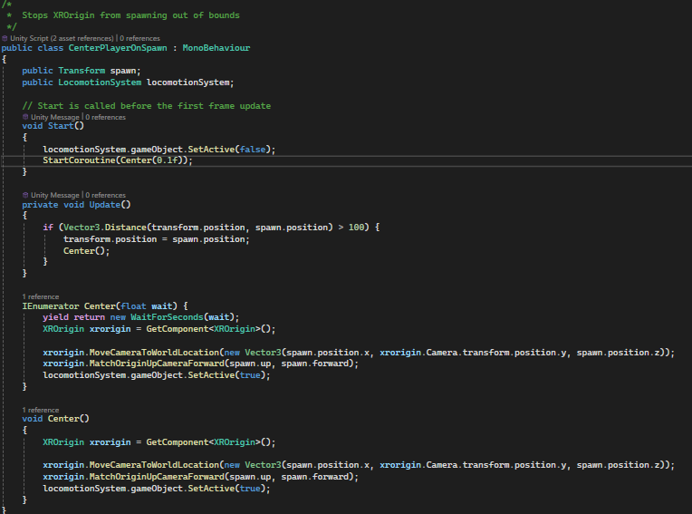

33 Improved Script for XROrigin out-of-bounds correction.

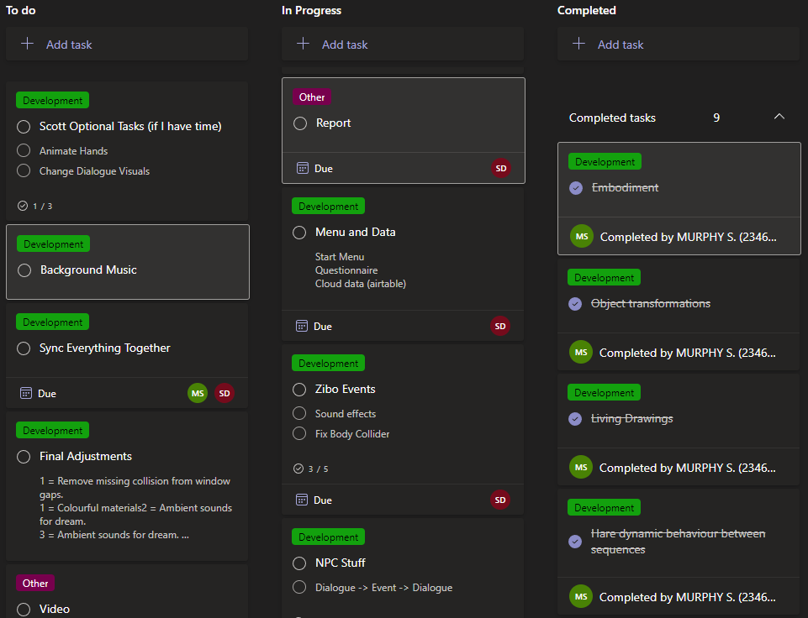

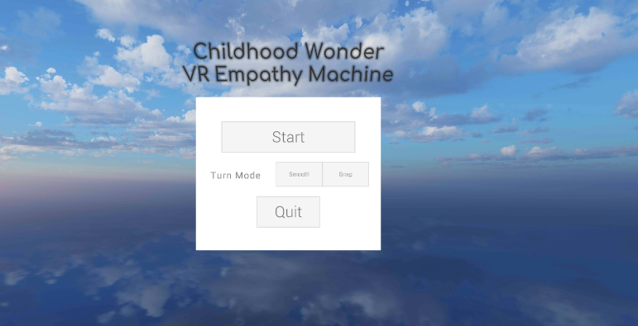

34 Menu scene for settings turn mode, and gathering participant information like age which will be uploaded to cloud data storage.

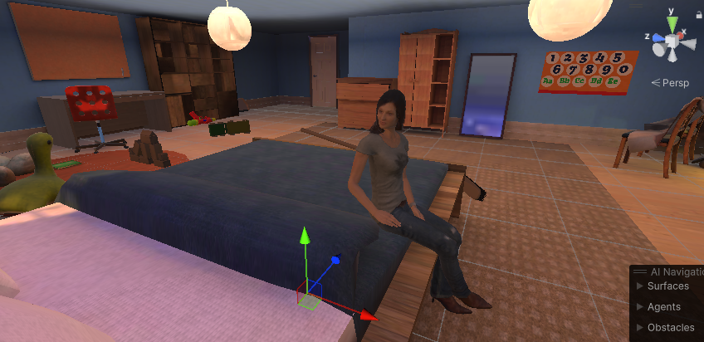

35 Quick segment with the mother at the end of the menu selection to introduce the Dream sequence.

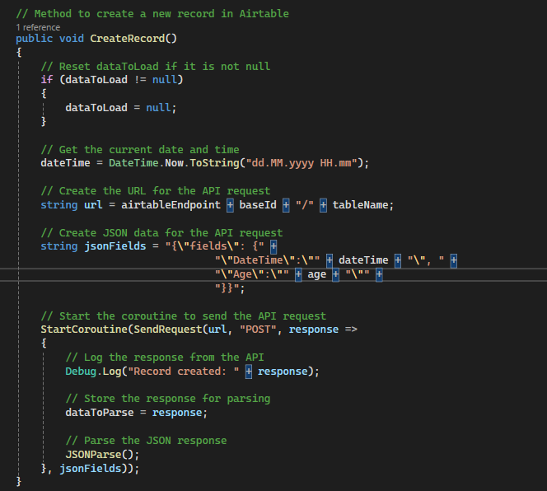

36 Modified the AirTable script from the module to register the time and the age the participant chooses from the dropdown menu. Additional data fields will be added to track wondrous event completion time.

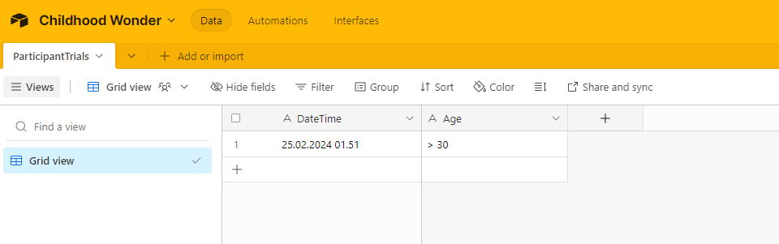

37 First functioning AirTable entry.